MY SQL QUERIES
Car Insurance Project

Change Column name ï»¿ID To Id_no
ALTER TABLE car_insurance
CHANGE COLUMN `ï»¿ID` Id_no VARCHAR(50);

DATA TYPES OF DIFFERENT COLUMNS
DESCRIBE Car_Insurance;
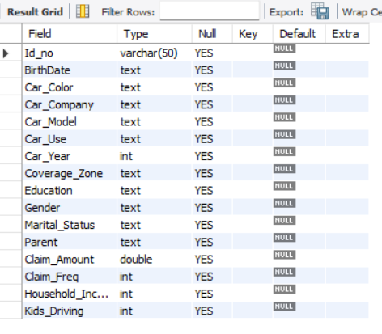

Total Claim Amount KPI
SELECT
CONCAT(ROUND(SUM(Claim_Amount) / 1000000, 2),
'M') AS Total_claim_amt
FROM
car_insurance;
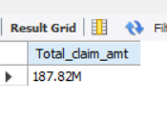

Explaination
SELECT clause:
- CONCAT(ROUND(SUM(Claim_Amount) / 1000000, 2), 'M') AS Total_claim_amt
  - SUM(Claim_Amount): Adds up all the values in the Claim_Amount column to get the total claim amount from all records.
  - / 1000000: Divides the total claim amount by 1,000,000 to convert it into millions for easier readability.
  - ROUND(..., 2): Rounds the result to 2 decimal places, making the value more presentable (e.g., 25.456 → 25.46).
  - CONCAT(..., 'M'): Adds the letter ‘M’ at the end of the number to indicate that the value is in millions (e.g., 25.46M).
  - AS Total_claim_amt: Assigns an alias name Total_claim_amt to the final output column for clarity.

FROM clause:
- car_insurance: Specifies the table from which the data (Claim_Amount) is being selected.

Business Insight:
• The insurance company wants to check the total claim amount received from various sources.
• They need to analyze the data across different dimensions such as car company, car make, and other related factors.
• The goal is to quickly and efficiently access this information for reporting and decision-making.
• This helps the company understand the overall financial impact of claims on the business.

TOTAL Polices KPI
SELECT
CONCAT(ROUND(COUNT(Id_no) / 1000, 2), 'K') AS total_policies
FROM
car_insurance;
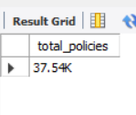
Explaination
SELECT clause:
• COUNT(Id_no) → Counts the total number of policy IDs in the table. Each ID represents one issued policy.
• / 1000 → Divides the total by 1,000 to convert it into thousands.
• ROUND(..., 2) → Rounds the result to two decimal places for clarity.
• CONCAT(..., 'K') → Adds the letter ‘K’ to show the value is in thousands (e.g., 12.45K).
• AS total_policies → Assigns a readable name to the output column.

FROM clause:
• car_insurance → Specifies the table containing all insurance policy data.
Business Insight:
• This query shows how many total policies are present in the table.
• It helps to understand the number of insurance policies claimed or held by individuals in the dataset.
• By viewing the total count, we can quickly identify how many people have taken insurance.
• It also helps analyze the company’s overall customer coverage and business reach.

AVERAGE Claim Amount KPI
SELECT
CONCAT(ROUND(AVG(claim_Amount) /1000, 2), 'K') AS Avg_claim_amt
FROM
car_insurance;
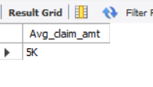
Explaination:
SELECT clause:
• AVG(Claim_Amount) → Calculates the average claim value from all records.
• / 1000 → Converts the value into thousands for simpler interpretation.
• ROUND(..., 2) → Rounds the result to two decimal places.
• CONCAT(..., 'K') → Adds the letter ‘K’ to show the amount is in thousands.
• AS Avg_claim_amt → Assigns a clear name to the output column.
FROM clause:
• car_insurance → Specifies the table containing all claim records.

Business Insight:
• This query shows the average claim amount from all insurance records.
• It helps the company check whether the average claim value meets or exceeds their expected target.
• If the average amount is higher than expected, it may indicate more costly claims.
• If it is lower than expected, it means the company’s claim payouts are under control.

AVERAGE CLAIM FREQUENCY KPI
SELECT
AVG(claim_freq) AS Claim_freq
FROM
car_insurance;
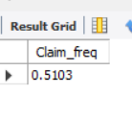
Explanation:
SELECT clause:
• AVG(claim_freq) → Calculates the average value of the claim frequency column.
• AS Claim_freq → Gives a readable name to the result column.
FROM clause:
• car_insurance → Refers to the table containing all claim data

Business Insight:
• This query shows the claim frequency of people in the dataset.
• It indicates how many customers have made claims and how many times they have claimed.
• It helps the company understand the claiming behaviour of policyholders.
• The result shows whether most customers are claiming often or rarely.

NUMBER OF MALE AND FEMALE KPI
SELECT
CONCAT(ROUND(COUNT(Id_no) / 1000, 2), 'K') AS Male_count
FROM
car_insurance

SELECT
CONCAT(ROUND(COUNT(Id_no) / 1000, 2), 'K') AS Male_count
FROM
car_insurance
WHERE
Gender = 'Female';

Explanation:
SELECT clause:
• COUNT(Id_no) → Counts the total number of female policyholders based on their ID.
• / 1000 → Converts the count into thousands for easy readability.
• ROUND(..., 2) → Rounds the value to two decimal places.
• CONCAT(..., 'K') → Adds the letter ‘K’ to indicate the result is in thousands.
• AS Female_count → Assigns a meaningful name to the result column.
FROM clause:
• car_insurance → The table containing all policy and customer information.
WHERE clause:
• Gender = 'Female' → Filters the data to include only female customers.

Business Insight:
• This query helps to check how many female policyholders are present in the dataset.
• It allows the company to compare the number of male and female customers.
• It gives a quick view of the gender distribution within the insurance data.

Charts

Car USE (DONUT CHART)–Total Claim Amount and Total Polices
SELECT
Car_use,
Claim_Amt,
CONCAT(ROUND(Claim_Amt * 100 / SUM(Claim_Amt) OVER (), 2), '%') AS Percentage
FROM (
SELECT
Car_use,
CONCAT(ROUND(SUM(Claim_Amount)/1000000,2),"M") AS Claim_Amt
FROM
car_insurance
GROUP BY Car_use
) AS Ab;
Explanation:
SELECT clause:
• Car_use → Retrieves the type of car usage (e.g., Private, Commercial).
• SUM(Claim_Amount) → Calculates the total claim amount for each car usage category.
• / 1000000 → Converts the total amount into millions for easier readability.
• ROUND(..., 2) → Rounds the claim amount to two decimal places.
• CONCAT(..., 'M') → Adds ‘M’ to indicate that the value is represented in millions.
• SUM(Claim_Amt) OVER() → Calculates the total claim amount across all car usage types using a window function.
• Claim_Amt * 100 / SUM(Claim_Amt) OVER() → Finds the percentage contribution of each car usage type to the overall total.
• CONCAT(..., '%') → Adds the percentage symbol to make the output more understandable.
• AS Claim_Amt_in_Million, AS Percentage → Assigns labels to the output columns.
FROM clause:
• The inner query groups and sums the claim amount for each Car_use from the car_insurance table.
• The outer query uses these grouped values to calculate each category’s share in millions and percentage format.
GROUP BY clause:
• Car_use → Groups all data by the type of car usage so that each category’s total claim amount is calculated separately.

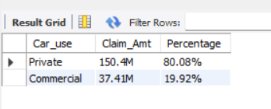
SELECT
Car_use,
CONCAT(ROUND(Total_Policies / 1000, 2), 'K') AS Total_Policies_in_Thousands,
CONCAT(ROUND(Total_Policies * 100 / SUM(Total_Policies) OVER (), 2), '%') AS Percentage
FROM (
SELECT
Car_use,
COUNT(Id_no) AS Total_Policies
FROM
car_insurance
GROUP BY Car_use
) AS Ab;
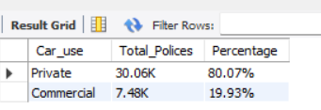

SELECT clause:
• Car_use → Retrieves the type of car usage (e.g., Private, Commercial).
• COUNT(Id_no) → Counts how many insurance policies are linked to each car usage category.
• / 1000 → Converts the total policy count into thousands for readability.
• ROUND(..., 2) → Rounds the value to two decimal places.
• CONCAT(..., 'K') → Adds ‘K’ to indicate values are in thousands.
• SUM(Total_Policies) OVER() → Calculates the total number of policies across all car usage types.
• Total_Policies * 100 / SUM(Total_Policies) OVER() → Finds the percentage share of each car usage category.
• CONCAT(..., '%') → Adds a percentage symbol for clarity.
• AS Total_Policies_in_Thousands, AS Percentage → Assigns names to the output columns.
FROM clause:
• The inner query counts the total number of insurance policies for each Car_use from the car_insurance table.
• The outer query converts those counts into thousands and calculates each category’s percentage contribution.
GROUP BY clause:
• Car_use → Groups the dataset by car usage type so that the total policies for each category can be calculated separately.

Business Insight For Total Claim Amt and Total Polices :
• We observe that Private vehicles are higher in number compared to Commercial vehicles in terms of total policies.
• The total claim amount is almost balanced between Private and Commercial vehicles.
• This shows that even though more Private vehicles have insurance policies, Commercial vehicles also contribute significantly to total claim amounts.
• The analysis indicates that more claims have come from Private vehicles because of their larger policy base.
• By checking the charts, we can see that Commercial vehicles are lagging in policy count.
• Overall, Private vehicles have an upper hand both in the number of policies and in total claims raised.

Car Company (LINE CHART)–Total Claim Amount and Total Polices

SELECT
Car_Company, CONCATROUND(SUM(Claim_Amount), 2),”M”) AS claim_amt
FROM
car_insurance
GROUP BY Car_Company
ORDER BY claim_amt DESC
LIMIT 10;
Explanation:
SELECT clause:
• Car_Company → Retrieves the name of the car manufacturing company from the dataset.
• SUM(Claim_Amount) → Calculates the total claim amount submitted for each car company.
• / 1000000 → Converts the total claim amount into millions for better readability.
• ROUND(..., 2) → Rounds the claim amount to two decimal places.
• CONCAT(..., 'M') → Adds the letter ‘M’ to indicate that the value is represented in millions.
• AS claim_amt → Assigns a label (alias) to the calculated column so it appears as ‘claim_amt’ in the output.
FROM clause:
• car_insurance → Refers to the main table that contains all information about car companies, policies, and claim amounts.
GROUP BY clause:
• Car_Company → Groups the records by car company so the total claim amount can be calculated separately for each brand.
ORDER BY clause:
• SUM(Claim_Amount) DESC → Sorts the companies in descending order based on their total claim amount, showing the companies with the highest claims first.
LIMIT clause:
• LIMIT 10 → Displays only the top 10 car companies with the highest total claim amounts to make the result concise and focused.

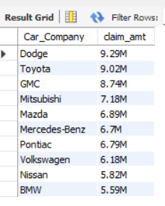
SELECT
Car_Company, CONCAT(ROUND(COUNT(Id_no)/1000, 2),"K") AS Total_Polices
FROM
car_insurance
GROUP BY Car_Company
ORDER BY Total_Polices DESC
LIMIT 10;
Explanation:
SELECT clause:
• Car_Company → Retrieves the name of each car company from the dataset.
• COUNT(Id_no) → Counts the total number of insurance policies associated with each car company.
• / 1000 → Converts the policy count into thousands for easy understanding.
• ROUND(..., 2) → Rounds the result to two decimal places.
• CONCAT(..., 'K') → Adds ‘K’ to show that the value represents thousands.
• AS Total_Policies → Assigns a label to the calculated column for better readability.
FROM clause:
• car_insurance → Refers to the dataset containing all details about car insurance, including car company and policy IDs.
GROUP BY clause:
• Car_Company → Groups the records by each car company so that total policies can be counted per brand.
ORDER BY clause:
• COUNT(Id_no) DESC → Sorts the results in descending order to show the car companies with the most insurance policies first.
LIMIT clause:
• LIMIT 10 → Displays only the top 10 car companies with the highest number of insurance policies.
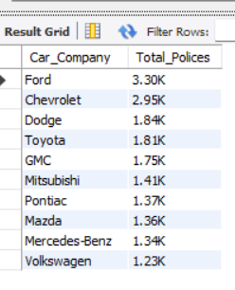
Business Insight For Total Claim Amt and Total Polices by Company :
- The top car companies contribute the highest number of policies and claim amounts.
- This shows that popular car brands have a larger customer base and higher claim activity.
- A direct link exists between the number of policies and total claims — companies with more insured vehicles tend to have more claims.
- These insights help the insurance company identify high-impact car brands and manage claim risks effectively.

Coverage Zone(Donut Chart) – Total Claim Amount and Total Polices
SELECT
Coverage_zone,
Concat(Round(claim_amt/1000000,2),"M")as Claim_Amt,
concat(ROUND(claim_amt / SUM(claim_amt) OVER () * 100, 2),"%") AS percentage
FROM (
SELECT
Coverage_zone,
SUM(Claim_Amount)AS claim_amt
FROM car_insurance
GROUP BY Coverage_zone
) AS sub;
Explanation:
SELECT clause:
• Coverage_zone → Retrieves the insurance coverage area (for example: Urban, Rural, or Suburban).
• Concat(Round(claim_amt/1000000,2),"M") AS Claim_Amt → Converts the total claim amount into millions, rounds it to two decimal places, and adds “M” for better readability.
• concat(ROUND(claim_amt / SUM(claim_amt) OVER () * 100, 2),"%") AS percentage → Calculates what percentage of the total claim amount each coverage zone contributes.
FROM clause (subquery):
• Inside the subquery, SUM(Claim_Amount) adds up all claim amounts for each coverage zone.
• GROUP BY Coverage_zone ensures the total is calculated separately for each zone.
Main query:
• Uses the summarized results to display total claim amount per zone (in millions) and its percentage share of the overall claim total.

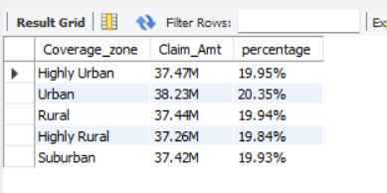
SELECT
Coverage_zone,
CONCAT(ROUND(Total_Polices / 1000,2),"K") AS Total_Polices,
CONCAT(ROUND(Total_Polices * 100 / SUM(Total_Polices)OVER(),2),"%") AS Percentage
FROM
(
SELECT
Coverage_zone,
COUNT(Id_no)AS Total_Polices
FROM
car_insurance
GROUP BY Coverage_zone
) AS AC;
Explanation:
SELECT clause:
• Coverage_zone → Retrieves each coverage area (e.g., Urban, Rural, Suburban).
• ROUND(Total_Polices / 1000, 2) → Converts policy count into thousands for easier readability.
• CONCAT(..., "K") → Adds “K” to represent thousands.
• SUM(Total_Polices) OVER() → Calculates the total policies across all zones.
• (Total_Polices * 100 / SUM(Total_Polices) OVER()) → Computes the percentage share of each zone’s policies.
• CONCAT(..., "%") → Displays the result as a percentage.
FROM clause:
• Uses a subquery to first calculate the total number of policies per coverage zone.
GROUP BY clause:
• Groups data by Coverage_zone to get aggregated results for each zone.
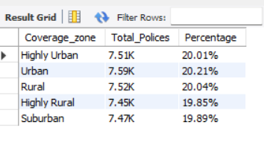

Business Insight For Total Claim Amt and Total Polices by Coverage Zone:
• Claim amounts and total policies are not equally distributed across coverage zones.
• The urban zone has the highest claim amount.
• Urban areas also have more insurance policies compared to other zones.
• This indicates that most insured vehicles and claims come from urban regions.
• The company’s major business activity and financial exposure are concentrated in urban areas.

CAR YEAR (Line Chart) – Total Claim Amount and Total Polices
SELECT
Car_Year, CONCAT(ROUND(SUM(Claim_Amount)/1000000, 2),"M") AS claim_amt
FROM
car_insurance
WHERE
Car_Year>=1990
GROUP BY Car_Year;
Explanation:
SELECT clause:
• Car_Year → Retrieves the manufacturing year of each car.
• SUM(Claim_Amount) → Calculates the total claim amount for each car year.
• /1000000 → Converts the total claim amount into millions for easier readability.
• ROUND(..., 2) → Rounds the result to two decimal places.
• CONCAT(..., "M") → Adds “M” to indicate the amount is in millions.
• AS claim_amt → Assigns an alias name claim_amt to the resulting column.
FROM clause:
• car_insurance → Specifies the table containing claim and car details.
WHERE clause:
• Car_Year >= 1990 → Filters the data to include only cars manufactured in or after 1990.
GROUP BY clause:
• Car_Year → Groups records by each car year to calculate total claim amounts separately for each year.
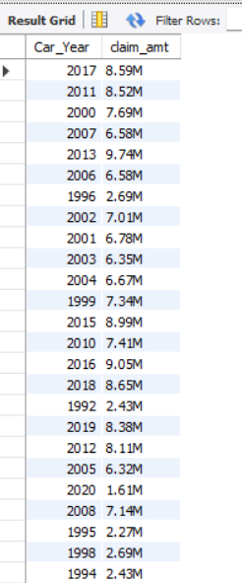
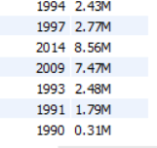

SELECT
Car_Year,
CONCAT(ROUND(COUNT(Id_no)/1000, 2),"K") AS Total_Polices
FROM
car_insurance
WHERE
Car_Year >= 1990
GROUP BY
Car_Year;
EXPLANATION:
SELECT CLAUSE:
• Car_Year → Retrieves the manufacturing year of each car.
• COUNT(Id_no) → Counts how many insurance policies or claims exist for that year.
• /1000 and ROUND(..., 2) → Converts the count into thousands and rounds it to two decimal places.
• CONCAT(..., "K") → Adds “K” to indicate the count is in thousands.
• AS Total_Polices→ Labels the output column as Total_Polices.
FROM clause:
• car_insurance → Retrieves data from the insurance dataset.
WHERE clause:
• Car_Year <= 1990 → Filters results to include only cars manufactured in or before 1990.
GROUP BY clause:
• Groups results by each car year to calculate total policies or claims for that year.

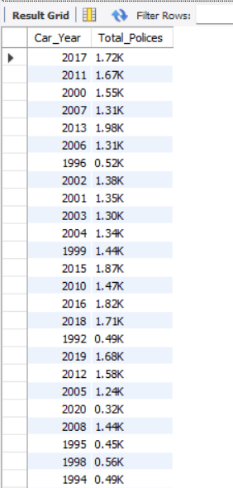

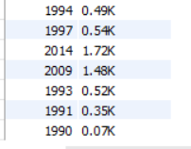
Business Insight For Total Claim Amt and Total Polices by Car Year:
• The analysis focuses on cars manufactured after 1990, as earlier years had very few claims.
• After 1990, both total claims and total policies have shown a steady increase year by year.
• This indicates a growth in the insurance market and greater awareness among car owners.
• The trend suggests that newer vehicles are more insured and contribute more to the company’s total claim amount.

Age Group(Clustered Column Chart) – Total Claim Amount and Total Polices
SELECT
CASE
WHEN TIMESTAMPDIFF(YEAR, STR_TO_DATE(BirthDate, '%d-%m-%Y'), CURDATE()) BETWEEN 15 AND 25 THEN '15-25'
WHEN TIMESTAMPDIFF(YEAR, STR_TO_DATE(BirthDate, '%d-%m-%Y'), CURDATE()) BETWEEN 26 AND 35 THEN '25-35'
WHEN TIMESTAMPDIFF(YEAR, STR_TO_DATE(BirthDate, '%d-%m-%Y'), CURDATE()) BETWEEN 36 AND 45 THEN '36-45'
WHEN TIMESTAMPDIFF(YEAR, STR_TO_DATE(BirthDate, '%d-%m-%Y'), CURDATE()) BETWEEN 46 AND 55 THEN '46-55'
WHEN TIMESTAMPDIFF(YEAR, STR_TO_DATE(BirthDate, '%d-%m-%Y'), CURDATE()) BETWEEN 56 AND 65 THEN '56-65'
WHEN TIMESTAMPDIFF(YEAR, STR_TO_DATE(BirthDate, '%d-%m-%Y'), CURDATE()) BETWEEN 66 AND 75 THEN '66-75'
ELSE '75+'
END AS Age_Group,
CONCAT(ROUND(SUM(Claim_Amount)/1000000,2),"M") AS Total_Claim
FROM car_insurance
GROUP BY Age_Group
ORDER BY Age_Group;
EXPLANATION:
SELECT clause:
• CASE ... END AS Age_Group → Creates age groups by calculating each customer’s age from their birthdate.
- TIMESTAMPDIFF(YEAR, STR_TO_DATE(BirthDate, '%d-%m-%Y'), CURDATE()) → Calculates the difference in years between the customer’s birth date and the current date, i.e., their age.
- The CASE statement classifies each age into groups like 15–25, 26–35, 36–45, and so on.
- If the age is above 75, it’s categorized as 75+.
• SUM(Claim_Amount) → Adds up all claim amounts for each age group.
• /1000000 → Converts the claim amount into millions for easier reading.
• ROUND(..., 2) → Rounds the total to two decimal places.
• CONCAT(..., "M") → Adds “M” to show the total in millions.
• AS Total_Claim → Labels the result column as Total_Claim.
FROM clause:
• car_insurance → Retrieves data from the insurance dataset containing birth dates and claim amounts.
GROUP BY clause:
• Groups all data by Age_Group, so the total claim amount is calculated for each age category.
ORDER BY clause:
• Sorts the results in ascending order of the Age_Group.
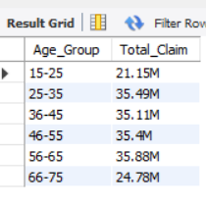

SELECT
CASE
WHEN TIMESTAMPDIFF(YEAR, STR_TO_DATE(BirthDate, '%d-%m-%Y'), CURDATE()) BETWEEN 15 AND 25 THEN '15-25'
WHEN TIMESTAMPDIFF(YEAR, STR_TO_DATE(BirthDate, '%d-%m-%Y'), CURDATE()) BETWEEN 26 AND 35 THEN '25-35'
WHEN TIMESTAMPDIFF(YEAR, STR_TO_DATE(BirthDate, '%d-%m-%Y'), CURDATE()) BETWEEN 36 AND 45 THEN '36-45'
WHEN TIMESTAMPDIFF(YEAR, STR_TO_DATE(BirthDate, '%d-%m-%Y'), CURDATE()) BETWEEN 46 AND 55 THEN '46-55'
WHEN TIMESTAMPDIFF(YEAR, STR_TO_DATE(BirthDate, '%d-%m-%Y'), CURDATE()) BETWEEN 56 AND 65 THEN '56-65'
WHEN TIMESTAMPDIFF(YEAR, STR_TO_DATE(BirthDate, '%d-%m-%Y'), CURDATE()) BETWEEN 66 AND 75 THEN '66-75'
ELSE '75+'
END AS Age_Group,
CONCAT(ROUND(COUNT(Id_no)/1000,2),"K") AS Total_Polices
FROM car_insurance
GROUP BY Age_Group
ORDER BY Age_Group;
EXPLANATION:
SELECT clause:
• CASE ... END AS Age_Group → Creates custom age groups based on each customer’s age.
- TIMESTAMPDIFF(YEAR, STR_TO_DATE(BirthDate, '%d-%m-%Y'), CURDATE()) → Calculates the customer’s age by finding the difference in years between their birth date and the current date.
- Depending on the age, customers are categorized into groups like 15–25, 26–35, 36–45, and so on.
- Anyone above 75 years old is grouped as 75+.
• COUNT(Id_no) → Counts how many insurance policies (or customers) belong to each age group.
• /1000 → Converts the total count into thousands for easier readability.
• ROUND(..., 2) → Rounds the number to two decimal places.
• CONCAT(..., "K") → Adds “K” to represent the value in thousands.
• AS Total_Polices → Labels the output column as Total_Polices.
FROM clause:
• car_insurance → Specifies the dataset containing customer details and their birthdates.
GROUP BY clause:
• Groups the records by Age_Group, so total policies are calculated for each age range.
ORDER BY clause:
• Sorts the results in ascending order of Age_Group.
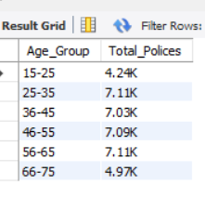
Business Insight For Total Claim Amt and Total Polices by Age Group:
- Customers aged 35 to 65 have more claims and total policies compared to other age groups.
- Middle-aged individuals are more likely to own vehicles and purchase insurance.
- They are also more active in filing claims, possibly due to higher vehicle usage or better financial awareness.
- Other age groups show lower but steady participation without a major drop.
- Overall, insurance demand is strong across all ages, with a clear peak between 35 and 65 years.

Kids Driving(Funnel Chart) – Total Claim Amount and Total Polices

SELECT
Kids_Driving, CONCAT(ROUND(SUM(Claim_Amount)/1000, 2),"K") AS claim_amt
FROM
car_insurance
GROUP BY Kids_Driving;
EXPLANATION:
SELECT clause:
• Kids_Driving → Represents whether kids are allowed to drive the car (Yes or No).
• SUM(Claim_Amount) → Calculates the total claim amount for each category of Kids_Driving.
• /1000 → Converts the claim amount into thousands for easier readability.
• ROUND(..., 2) → Rounds the value to two decimal places for cleaner presentation.
• CONCAT(..., "K") → Adds “K” at the end of the value to represent the total in thousands.
• AS claim_amt → Labels the final output column as claim_amt (total claim amount).
FROM clause:
• car_insurance → Specifies the dataset containing car insurance details, including claim amounts and whether kids are driving.
GROUP BY clause:
• Groups all records by Kids_Driving, so the total claim amount is calculated separately for each category (Yes or No).
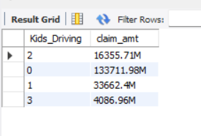
SELECT
Kids_Driving, CONCAT(ROUND(Count(Id_no)/1000, 3),"K")AS Total_Polices
FROM
car_insurance
GROUP BY Kids_Driving
ORDER BY Count(Id_no) Desc;
EXPLANATION:
SELECT clause:
• Kids_Driving → Indicates whether kids are allowed to drive the car (Yes or No).
• COUNT(Id_no) → Counts the total number of insurance policies for each category of Kids_Driving.
• /1000 → Converts the count into thousands for easier readability.
• ROUND(..., 3) → Rounds the number to three decimal places for better presentation.
• CONCAT(..., "K") → Adds “K” to represent the total in thousands.
• AS Total_Polices → Labels the output column as Total_Polices.
FROM clause:
• car_insurance → Refers to the dataset that contains insurance records, including details about whether kids drive the car.
GROUP BY clause:
• Groups the records by Kids_Driving so that the total number of policies is calculated separately for each category (Yes or No).
ORDER BY clause:
• Sorts the results in descending order based on the count of policies, so the category with the highest number of policies appears first.
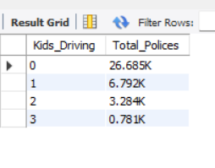
Business Insight For Total Claim Amt and Total Polices by Kids Driving:
- Adult drivers have the highest number of claims and total policies.
- They represent the main insured group in the dataset.
- Kids or underaged drivers have very few claims.
- High total policies for kids may be due to family or shared vehicle coverage.
- Adult drivers are the key focus for insurance companies when analyzing risk and setting premiums

Education (Donut Chart) – Total Claim Amount and Total Polices
SELECT
Education,
CONCAT(ROUND(claim_amt/1000000,2),"M"),
concat(ROUND(claim_amt / SUM(claim_amt) OVER () * 100, 2),"%") AS percentage
FROM (
SELECT
Education,
SUM(Claim_Amount)AS claim_amt
FROM car_insurance
GROUP BY Education
) AS sub;

EXPLANATION:
SELECT clause:
- Education → Retrieves the education level of each policyholder.
- SUM(Claim_Amount) → Calculates the total claim amount for each education level.
- /1000000 → Converts the total claim amount into millions for better readability.
- ROUND(..., 2) → Rounds the value to two decimal places.
- CONCAT(..., 'M') → Appends "M" to show the value is in millions.
- AS Claim_Amt → Labels the column as Claim_Amt.
- (claim_amt / SUM(claim_amt) OVER() * 100) → Calculates the percentage contribution of each education level’s claim amount to the total claim amount.
- CONCAT(..., '%') → Adds a percentage symbol for clarity.
FROM clause:
- car_insurance → Refers to the dataset that contains education and claim amount details.
GROUP BY clause:
- Education → Groups data by education level to find total claim amount for each group.
Subquery alias (AS sub):
- Used to summarize claim amounts first and then calculate their percentage contribution in the outer query.
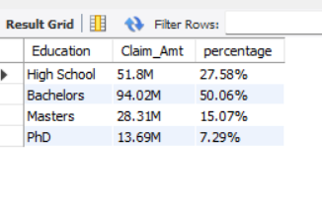
SELECT
Education,
Total_Polices,
CONCAT(ROUND(Total_Polices * 100.0 / SUM(Total_Polices) OVER (), 2), '%') AS percentage
FROM (
SELECT
Education,
CONCAT(ROUND(COUNT(Id_no)/1000,3),"K") AS Total_Polices
FROM car_insurance
GROUP BY Education
) AS sub;
EXPLANATION:
SELECT clause:
- Education → Retrieves each policyholder’s education level.
- COUNT(Id_no) → Counts how many insurance policies belong to each education category.
- /1000 → Converts the count into thousands for easier interpretation.
- ROUND(...,3) → Rounds the count value to three decimal places.
- CONCAT(...,"K") → Adds "K" to indicate the value is in thousands.
- AS Total_Polices → Assigns a label to the total number of policies column.
- (Total_Polices * 100 / SUM(Total_Polices) OVER()) → Calculates the percentage share of each education group out of the total policies.
- CONCAT(...,"%") → Adds a percentage symbol for better presentation.
FROM clause:
- car_insurance → The main dataset containing education level and policy details.
GROUP BY clause:
- Education → Groups the records by education level so that counts can be calculated per category.
Subquery alias (AS sub):
- Summarizes policy counts by education first, then calculates each group’s percentage in the outer query
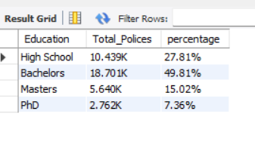
Business Insight For Total Claim Amt and Total Polices by Education:

• We can see that bachelor holders have claimed the highest amount and also hold the most insurance policies.
• This indicates that bachelor-level individuals are more aware of insurance benefits and actively use them.
• High school graduates come second in both total claim amount and total policies.
• This shows that education level has a direct influence on insurance awareness and claim activity.
• The company can focus on promoting policies among lower education groups to improve coverage balance.

Education and Martial Status (Matrix Chart) – Total Claim Amount and Total Polices
SELECT
Education,
Marital_Status,
CONCAT(ROUND(SUM(Claim_Amount)/1000000, 2),"M") AS claim_amt
FROM
car_insurance
GROUP BY Education , Marital_Status;
EXPLANATION:
SELECT clause:
• Education → Retrieves the education level of each policyholder.
• Marital_Status → Retrieves whether the person is married or single.
• SUM(Claim_Amount) → Calculates the total claim amount for each education and marital status group.
• /1000000 → Converts the claim amount into millions for easier understanding.
• ROUND(..., 2) → Rounds the value to two decimal places.
• CONCAT(..., "M") → Adds “M” to represent the value in millions.
• AS claim_amt → Labels the column as claim_amt in the output.
FROM clause:
• car_insurance → Refers to the dataset containing all policyholder and claim details.
GROUP BY clause:
• Groups the data by both education and marital status to show how claim amounts vary across these categories.

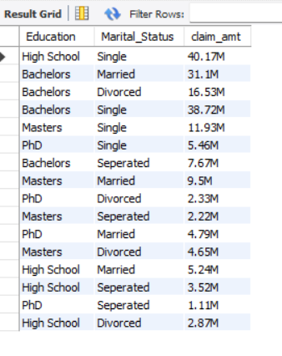
SELECT
Education,
Marital_Status,
CONCAT(ROUND(COUNT(Id_no)/1000, 3),"K") AS Total_Polices
FROM
car_insurance
GROUP BY Education , Marital_Status;
EXPLANATION:
SELECT clause:
• Education → Retrieves the education level of each policyholder.
• Marital_Status → Retrieves whether the policyholder is married or single.
• COUNT(Id_no) → Counts the number of insurance policies under each education and marital status group.
• /1000 → Converts the total count into thousands for easier readability.
• ROUND(..., 3) → Rounds the number to three decimal places.
• CONCAT(..., "K") → Adds “K” to represent the value in thousands.
• AS Total_Polices → Labels the result column as Total_Polices.
FROM clause:
• car_insurance → Refers to the dataset containing information about policyholders, their education, marital status, and policies.
GROUP BY clause:
• Groups the records based on both education and marital status so that total policies can be calculated for each combination.
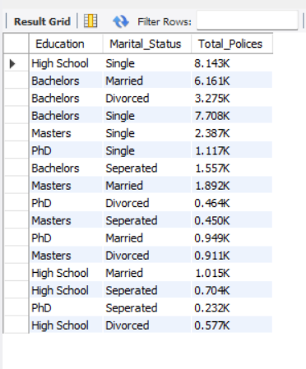
Business Insight For Total Claim Amt and Total Polices by Education:
• Married individuals with a bachelor’s education have both higher total claim amounts and a greater number of policies — showing they are more financially active and aware of insurance benefits.
• Single bachelor’s degree holders also show significant participation but slightly lower claim amounts, suggesting they prefer to hold policies but may claim less frequently.
• High school–educated policyholders have moderate claims and policy counts, indicating basic awareness but possibly lower income levels affecting claim activity.
• Lower-educated groups (below high school) show fewer policies and lower claim amounts, reflecting limited financial literacy or access to insurance.
• Overall, education and marital status together influence both the likelihood of purchasing insurance and the frequency of claims — with higher education levels leading to better insurance engagement.

